S I P O C
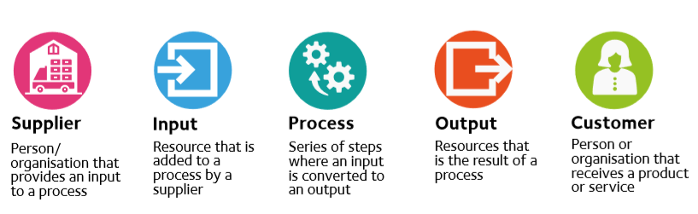

In addition to giving a high-level view of the process, the SIPOC diagram helps to answer the following questions, all of which must be understood before starting to gather data on the process:
- When does the process begin and end: What is the SCOPE?
- Who is affected by my project – suppliers and customers: Who are the STAKEHOLDERS?
- What are the inputs, outputs and key process steps: What could we MEASURE?
- What is this project working on: How can we COMMUNICATE about the project?

SIPOC
 | Suppliers | Inputs | Process | Outputs | Customer

