Feedback Form
Continuous Improvement
Benefits at a glance….
- It is simple and easy to use – for both you and the person providing the feedback – so you don't need to worry about asking too much of someone's time.
- Structured to help the reviewer provide feedback in a constructive way.
- By regularly using the form, you are introducing it to colleagues and helping to spread the culture of using feedback more widely across the organisation.

What is it?
It's a very simple tool to support on-going personal development.​ It structures feedback into: ​
- Positives - things that are going well or that you are doing well ​
- Opportunities – things that could be done better - opportunities for improvement​
- Development – the recipient's response to the feedback – their reflections on it, the insights it provides and what action they are going to take as a result​, as well as how to embed the positive skills and behaviours.

When to use it?
A highly flexible and versatile too, it can be used in many situations. For example, after:
- the conclusion of a piece of work that you produced or managed;
- an event or meeting that you contributed to or organised;
- changing the way you do something or approach a task;
- putting into practice some new training or learning;
- working with someone new for a few weeks.

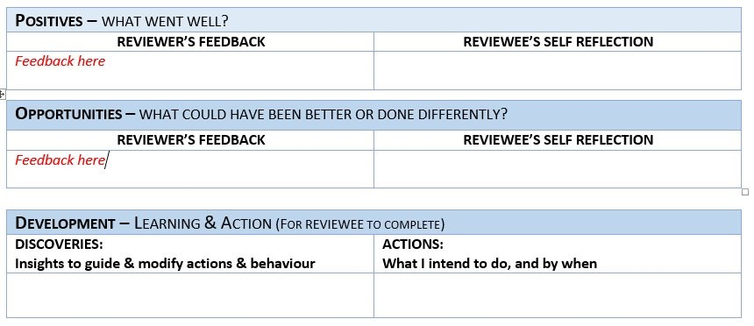Figure 1: Feedback form

How to use it?
It is a good idea to ask your reviewer in advance if they can provide you with feedback, rather than waiting until after the event or piece of work.

- Send the form to your chosen reviewer, having filled in the details at the top of the form so they know what it is you want feedback on.
- Ask them to complete the sections indicated for the Reviewer, and then return the form to you.
- Reflect carefully on the feedback you receive– you may not agree with the opportunities but try to think about why the reviewer has made the suggestions. Add your reflections to the form.
- Complete the Development section. Always try to have at least one action based on the feedback and a date when you will have done it.

Tips
- Plan ahead for collecting feedback. Think about what is coming up in your diary and opportunities to use one.
- Seek feedback from a variety of people when you have had some practice in seeking feedback. You will get a wider range of perspectives and greater insights if you cast your net wider.
- Be flexible about the format of the feedback – if the reviewer prefers to use email to answer the questions, that’s fine. Consider other options, such as creating a Microsoft form for reviewers to complete and submit.
- Keep and review your feedback at regular intervals - you may see a theme emerging that you would like to focus on in your personal development.
- Feedback Forms are for your personal use and do not need to be shared with anyone but you may find it helpful to use them to plan for your PDR or to support requests for training or other development.

