IT Infrastructure Service Review

Recommendations Report

July 2023

Contents

Contents 2
Executive Summary 3
Introduction 4
Part A – Supporting Information 4
Key drivers 4
Objectives 4
Scope 5
Qualitative benchmarking 5
Design phase approach 6
Consultation approach 6
Part B - Recommendations 7
1. A University-wide ‘Shared by default, bespoke by exception’ Service Delivery Model 7
2. New leadership and governance 8
2.1 Heads of Technology 8
2.2 University Technology Leadership Group 9
3. Change Programme Recommendations 9
3.1 Enhance understanding of existing IT infrastructure landscape within Divisions 9
3.2 Improve user experience through empowering local IT Staff 10
3.3 Improve collaborative working to capitalise on existing expertise 10
3.4 Attract, develop and retain IT infrastructure staff 10
3.5 Remove unnecessary duplication to reduce information security risks 11
3.6 Standardisation to improve value and efficiency 11
Implementation of Recommendations 11
High level implementation approach 13
Next Steps 13
Appendices 13

Executive Summary
The IT Infrastructure Service Review has reached the Recommendation stage. This report provides the recommendations agreed by the Oversight Board on 28th June.
The recommendations centre around the realisation of a new service delivery model for the University’s IT Infrastructure service whereby component services are designed so they are ‘shared by default and bespoke by exception’. The implications and benefits of such a model have been considered by the OB at its Diagnose workshop in April and the work of the Design phase has been to identify supporting actions that will lead to the operation of this model, respond to the drivers for the review and assist the University in progressing towards level 5 operating levels as per the definitions in the service assessment model (SAM). This model is recommended for the services in scope of this service review i.e. physical, servers and storage; networks; identify, platform and endpoint; and the underpinning information security considerations. The review is not recommending this model for the services which fell outside its scope of work, such as research specific or college IT infrastructure delivery, although many of the principles of the model may usefully be considered by other services.
Key recommendations include the introduction of a new University Technology Leadership Group, which will be represented at the University’s Technology Portfolio Committee. This group will provide leadership for the IT Infrastructure service. It will be responsible for enabling the transition towards the new shared delivery model and for providing senior IT leadership and consistent delivery of the wider recommendations of this review. Its membership will include new roles of Heads of Technology, who will have oversight of the IT Infrastructure delivery teams within each of the divisions and a dotted reporting line to the CIO. These roles will provide an interface between Divisions, Departments, IT Services and the new Digital Governance structures. Their leadership will drive organisational change and they will be essential to create the conditions needed to transition from a bespoke delivery model to a shared delivery model.
A detailed set of recommendations compiled through workshops with members of the project team, check and test group and wider IT infrastructure community, are included in support of the change programme. The high-level implementation approach and principles of the delivery model outlined here is supported by benchmarking discussions with four Russell Group Universities. The recommendations compliment and incorporate work carried out through the foundation stage of the Digital Transformation Programme in areas such as zero trust access management framework, University-wide managed WiFi service and identity management. Divisional boards and college committees have reviewed and provided feedback on the recommendations and have all been supportive of the overall approach.
The expectation set at the start of this review was that consideration should be given to the best use of existing resources before drawing on additional funds. A bid for ‘over and above’ funding to enable the higher ambitions for the IT Infrastructure service has been included in the Digital Transformation business case to Council. It will be incumbent on the Technology Leadership Group to ensure that the principles of a ‘shared by default and bespoke by exception’ model are incorporated in all of the activities and projects undertaken in support of the new service delivery model.
The first stages of the proposed implementation approach include detailed planning with divisions, to ensure an approach and timeframe appropriate to local need and organisational opportunities. The recommendations range from longer-term ‘big ticket' items such as University-wide managed desktops and a University-wide wired network, to shorter-term ‘quick win’ initiatives that might be progressed more quickly and enable real improvements to user experience, in areas such as skills development, permissions of local IT staff, knowledge sharing mechanisms and collaboration approaches. It is important that delivery of these quick wins is not constrained by the organisational or governance changes so that users and providers of the IT infrastructure service can experience improvements at the earliest opportunity.
In summary, the overall package of recommendations, united by a service delivery principle of ‘shared by default and bespoke by exception’, responds to the challenges and opportunities identified by stakeholders, and will lead to a more resilient, secure and effective infrastructure service that provides greater value for departments and improves user experience.

Introduction
Contained in Part A of this report are:
- The key drivers, objectives and scope of the review
- Summary of the benchmarking activity that has taken place
- Summary of the design phase and consultation approach
Part B of the report provides a summary of the recommendations. In agreeing these recommendations, the Oversight Board has taken care to ensure they meet the key drivers of the review, meet the challenges and opportunities identified in the diagnose phase, and are bold enough to respond to the future needs of the University whilst also being realistic, achievable and in tune with divisional priorities.
Readers of this report may find it helpful to refer to the IT Infrastructure Service Review Diagnose Report available at: IT Infrastructure Service Review Diagnose Report

Part A – Supporting Information

Key drivers
In conjunction with the Digital Transformation Programme, the aim of the review - across divisions, departments, and professional services – is to ensure our IT infrastructure is more joined-up, resilient, and secure; remove unnecessary duplication; maximise the value to users and departments; and reflect the principles of Professional Services Together.

Objectives
The key objectives for this Review have been shared with all who have participated in developing the proposals incorporated in this report. They are:
1. Develop an agreed set of operating levels within the service assessment model relevant to IT infrastructure at Oxford.
2. Carry out a baseline assessment of services as part of the work to build a shared and evidence-based understanding of the service, identifying what works well and should be retained, and where opportunity for improvement lies.
3. Consider the extent to which benchmarking with external organisations and the use of external assessment tools are relevant and helpful to the review’s objectives and use accordingly.
4. Identify improvements that: reflect stakeholder requirements (responsive to new or changing needs/demands); support the needs of the digital transformation programme; enable progression to agreed service levels.
5. Consider the new and growing demands on the network infrastructure from building management infrastructure (CCTV, alarms, metering, access control etc.) to the variety of devices with embedded CPUs and make recommendations for their future support arrangements.
6. Consider options for and recommend to the relevant governance bodies across the organisation, a service design and organisation structure for IT infrastructure services across the University (a ‘target operating model’), including where common approaches are beneficial and where variation is possible/desirable.
7. Develop a high-level proposal for implementation.

Scope
In summary, the scope of this review covers four main areas of infrastructure: Physical, servers and storage; Networks; Identity, platform and endpoint; and Information Security (across all areas):
Physical, Servers and Storage | Networks | Identity, Platform and Endpoint
Servers, eg. physical, virtual, cloud, Infrastructure as a service (IaaS)  Virtualisation/Orchestration eg. VMware, Amazon Web Services/Azure, Ubuntu MaaS  Data Centres & Server Rooms  Databases (shared database servers not application specific)  Storage, eg. Storage Area Network, Network attached storage  Operating Systems | Physical  Local Area Network (LAN)  Wide Area Network (WAN)  Wi-fi  Firewalls  Network Access Control (NAC)  Network services:  - Network Time Protocol (NTP)  - Domain Name System (DNS)  - Dynamic Host Configuration Protocol (DHCP) | Identity Services, including:  - Active Directory (AD)  - Azure AD  - Lightweight Directory Access Protocol (LDAP)/Kerberos  - Edirectory  Platform Services - File Management, Print Management Email, Audio Visual  Endpoints - Managed and Bring your own Device (BYOD)
Information Security: Information Governance and other compliance. Policies, procedures and controls
Note: College IT infrastructure delivery is not in scope of this review; however, colleges have been engaged throughout the review as key consumers of elements of IT infrastructure services. It is expected that they will also benefit from some of the improvements in service delivery that are recommended later in this report.

Qualitative benchmarking
Since the approval of the Diagnose/Findings report, and to inform the development of the recommendations for this review, benchmarking meetings have taken place with several infrastructure managers from Russell Group Universities: Kings College London, University College London, Edinburgh, and Cambridge. The interviews identified that:
- All institutions undertaken/ing standardisation process to reduce bespoke service delivery
- Aim for all is to work towards common technology and standards
- Introducing the change is a long-term activity (5+ years)
- Change often begins with single or cluster of departments adopting a new model
- Change often involves delocalisation of reporting lines to central teams but maintaining local deployment of IT staff
- Removal of internal recharging and review of funding models is normal
- Except for Cambridge, no other University has the 'patchwork' network service that Oxford has
- Change is often driven by information security or financial risk
- Research, especially in scientific areas, will require specialist IT support managed locally

Design phase approach
Following the OB Diagnose Workshop on 20 April, the review team ran a briefing session for the Check and Test Group to update them on the findings, before holding a workshop with them to discuss the service delivery model and to prioritise the diagnose outputs of quick wins and strategic projects. This was followed by three further workshops with stakeholders from across the University who had previously participated in the diagnose workshops. The output from these sessions was a set of prioritised ideas that these stakeholders thought would most significantly address some of the challenges identified during the diagnose phases.
The qualitative benchmarking undertaken with four Russell Group universities has further helped to prioritise the major IT change projects that are recommended to address information security risks, de-duplicate and improve economies of scale. This benchmarking has also supported the need for a concerted programme of work to undertake the organisational changes.
In addition, the project team has worked to develop the principles of the ‘Shared by Default, Bespoke by Exception’ delivery model considered at the OB Diagnose workshop, and the associated leadership and governance changes recommended to enable this model and to support the implementation of the ‘quick win’ and strategic changes recommended in this report.

Consultation approach
The key recommendations included in this report were discussed at divisional boards and committees between 30th May and 29th June as follows:
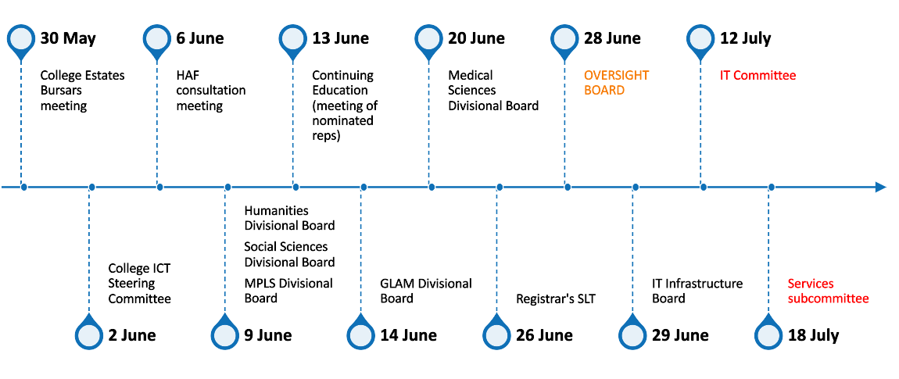
The divisional boards and committees were supportive of the direction of travel of the recommendations and particularly the need for leadership roles to co-ordinate and drive change forward. The Divisional boards re-emphasised the need for some bespoke services and identified risks about the interfaces between ‘standard’ infrastructure and research/scientific research being adversely affected. Additionally, the boards noted the impact that change has on staff and the need to manage this impact carefully. Questions of the future funding arrangements of services were raised that will need to be addressed during the next phase of implementation. Engagement with colleges emphasised that this review does not include in its scope the Colleges’ delivery of IT infrastructure. However, as a key consumer of some of the University’s IT infrastructure there will be an ongoing need for colleges to have a role in the design in future services and in the delivery of recommendations especially those that may have an impact on College IT resources.

Part B - Recommendations
The variety of structures involved in the delivery of the IT infrastructure service has led to a differentiation of services. The Diagnose phase of this service review found that whilst this differentiation allows bespoke or specialist needs to be met, there is a risk that the service delivery, organisational and funding models of the infrastructure service have differentiated to a point that it is no longer possible to be sure that the service is of consistent quality, nor that it is compliant, resilient and secure or providing value for money to departments. The degree of variation and examples of duplicated activity suggest opportunities for reviewing how we spend our money on IT infrastructure services and ensure it is directed to our priority areas.

The recommendations within this report seek to address the key challenges and opportunities highlighted by stakeholders during the Diagnose phase of this Service Review and to help the organisation to progress toward level 5 of the service assessment model.

The recommendations are made with the aim of implementing a shared infrastructure service over time, in accordance with an incremental transformation approach that can build on organisational opportunities as they arise. It is expected that through the implementation of the recommendations the University will realise a culture of trust, collaboration and shared endeavour in the delivery of the IT infrastructure service, which will bring benefits to both central and local IT teams. It is expected that Colleges will benefit from the improved trust arrangements to be introduced, in a similar way to University departments. Whilst consideration of IT Infrastructure provision within and by Colleges is out of scope for this review, it was considered that Colleges may wish to note the opportunities associated with a shared delivery model and explore the ways in which it could be useful to College IT infrastructure service delivery.
The recommendations can be categorised as follows:
1. A new service delivery model for the IT infrastructure service whereby services are designed so that they are shared by default and bespoke by exception.
2. A new leadership group for the IT infrastructure service including new roles of Heads of Technology that will have oversight of the IT Infrastructure delivery teams within each of the Divisions, and UAS/GLAM. This group will be responsible for enabling the transition towards the new shared delivery model and for ensuring consistency of the delivery of the wider recommendations of this review.
3. A series of wider recommendations to be delivered by a formal change programme that is overseen by the Technology Portfolio Committee and funded by Digital Transformation.

1. A University-wide ‘Shared by default, bespoke by exception’ Service Delivery Model
It has been accepted by the Oversight Board that the current Service Delivery model for the University’s IT infrastructure service is heavily weighted towards services that are being implemented in a bespoke way and that there are significant opportunities to adopt common technologies, processes and/or standards and therefore deliver these services in a shared way.
A key underpinning recommendation of this review is that IT infrastructure service design should in future, at all levels of the University, aim for shared services, proportionate to the nature and scale of the service.
Within this model, use of shared services would allow continuity of local decisions over WHAT is delivered but HOW it is done would be determined through use of common technologies and/or platforms, processes and standards. Noting that delivery location will be dictated by the most appropriate service provider, not by organisational structure, i.e. not assuming that all shared delivery is by IT Services. Whilst it is recognised that not all departments / divisions will be able to adopt common technologies and/or platforms or standards at the same pace, all levels of the organisation must be involved in determining these common technology, standards and process from the outset. The suggested implementation plan at the end of this report takes this into consideration.
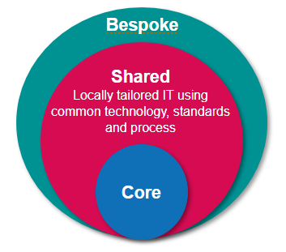
The guiding principles of this service delivery model are:
- Standards for service delivery are agreed and common technologies are used across the University.
- Common technologies and/or platforms are used which allow for local configuration in accordance with common standards and procedures.
- IT Infrastructure staff are located across the University in a structure which means that users benefit from best placed support.
- There is cross-team and platform collaboration.
- Bespoke services are delivered only where existing standards and platforms cannot adequately meet business need, and where the department concerned is prepared to underwrite the additional cost and risk.
- The structure and funding model should enable a bespoke service to evolve into a shared service where that service meets a broader set of university requirements.
- To encourage adoption of common technologies and/or platforms, and services these should, as far as possible, be free at the point of use.
Indicative examples to show how network, server and endpoint services could look like in the future are in Appendix: Model Examples
It should be noted that given the broad applicability of this ‘onion’ model it is anticipated that these principles should be adopted more widely across other services.

2. New leadership and governance
The creation of new roles of Head of Technology and the University Technology Leadership Group are fundamental to creating an environment in which the shared by default, bespoke by exception model can be realised.

2.1 Heads of Technology
It is recommended that the role of Head of Technology be created, one for each of the academic divisions and a single joint role for GLAM, UAS and Continuing Education.
Due to the differences in size, shape and focus of IT delivery in each of the Divisions and UAS, the composition and role of the Head of Technology will differ dependent on location but will all be senior leadership roles which will act as champions for the shared by default service delivery model. The postholders will drive cultural and technological change in their divisions through:
- Development of a strategy to transition from a distributed IT infrastructure delivery model to a shared IT infrastructure delivery model
- Creation of conditions for collaborative engagement within the Division and the wider-University to realise the aims of the shared service delivery model
- Liaison between Divisional leadership, IT Services, and Digital Governance bodies to ensure alignment and compliance with organisational goals and policies
- Alignment with Academic and other IT leadership in Divisions
- Overseeing the implementation of the IT Infrastructure Service Implementation Programme
Each of the Heads of Technology will report to a nominated Divisional officer, will integrate with existing divisional leadership structures for IT and have a dotted reporting line to the CIO. These roles will have oversight of the IT Infrastructure delivery teams within each of the Divisions to facilitate the transition towards the shared delivery model. They will be active members of the University Technology Leadership Group.

2.2 University Technology Leadership Group
Represented at the University's Technology Portfolio Committee, the group will comprise the Heads of Technology, Director of Infrastructure IT Services, and the Enterprise Architect (further roles may be co-opted as required).
The group’s role is expected to develop over time, ensuring that it is aligned with other University initiatives and programmes of work in the digital sphere and beyond. In the first instance its focus will be on ensuring a coordinated approach to transitioning to a new service delivery model:
- Developing standards
- Enabling collaboration
- Identifying opportunities for alignment
- Reviewing existing services
- Strategic Leadership for the delivery of the recommendations of this review
- Ensuring potential new services are actively considering the new service delivery model principles and standards in design

3. Change Programme Recommendations
These recommendations have been compiled following design phase workshops with members of the Project Team, Check & Test Group, and wider IT infrastructure community as well as through discussions with other Russell Group Universities and internal stakeholders. Further details can be found in Appendix: Table of Recommendations
The recommendations below are expected to form an initial blueprint for a programme of work overseen by a programme board reporting to the new Technology Portfolio Committee. However, it is expected that some of the ‘quick win’ recommendations could be implemented with light touch oversight and in some areas, in advance of the wider programme. These have been marked in Appendix Table of Recommendations and on the high-level implementation plan.
It should be noted that the review team are aware that the Digital Transformation Programme has been carrying out investigations into a number of the areas covered below, and so there may be overlap with our recommendations (indicated below where known).

3.1 Enhance understanding of existing IT infrastructure landscape within Divisions
To leverage economies of scale and remove unnecessary duplication it is recommended that:
3.1.1 A common service catalogue of IT infrastructure services is created for each Division which will:
- Identify opportunities to undertake a shared approach to service delivery within the division and across the University
- Identify areas of expertise, and skills gaps, amongst IT Infrastructure staff
- Build a picture of the current costs of service delivery
3.1.2 Identify priority API or self-service interface investments in existing core services that would facilitate more local tailoring and widespread adoption reducing the need for bespoke duplicate services.
3.1.3 Embed management reporting against agreed SLAs/ standards, policies and procedures.

3.2 Improve user experience through empowering local IT Staff
To improve end user experience, consistency of service, and create the feeling of a single infrastructure service built on shared trust it is recommended that the University should:
3.2.1 Put in place sustainable mechanisms that allow ITSS direct access to IT infrastructure expertise, whether within IT Services or within other divisions, for example removing need for ITSS to use OSM/helpdesk
3.2.2 Increase devolution of access for local IT staff to expand and improve the support they can provide, e.g. allowing them to provision shared mailboxes and temporarily extend SSO end dates.
3.2.3 Provide local ITSS with permissions needed to support wider groups of end users, e.g., removing current affiliation-based restrictions on IT staff access (e.g. for password reset issues).
3.2.4 Scope a project to deliver a consistent support experience for end users, agnostic of organisational structures.
3.2.5 Review, and where necessary enhance, non-technical (user friendly) guidance on common IT issues (relating to the scope of this review).
3.2.6 Deploy single sign-on authentication as a shared service across a wider set of IT services in the University in order to improve the user experience and to simplify user support and systems management.

3.3 Improve collaborative working to capitalise on existing expertise
To establish collaborative working and capitalise on existing expertise to remove unnecessary duplication and improve user experience, it is recommended that the University should:
3.3.1 Use continuous improvement techniques, provide the ICT forum with a framework to establish a formalised community of practice for IT infrastructure service delivery with clear terms of reference, aims and objectives and sub-groups for specific IT infrastructure services.
3.3.2 Improve the guidance and support information that is currently available to ITSS via the ITSS wiki, Teams site, or similar.
3.3.3 Establish working groups to enable hybrid cloud integration across departments / divisions.
3.3.4 Create an environment conducive to the formation of specialist, fast response teams to target specific issues. The formation of the teams should enable swift resolution of cross-University IT infrastructure issues by identified experts in a short timeframe.

3.4 Attract, develop and retain IT infrastructure staff
To ensure staff have the skills required to deliver IT infrastructure services, it is recommended that the University should:
3.4.1 Develop an IT Infrastructure skills matrix with underpinning career pathways, training plans and skills gap analysis. The training plan should encompass opportunities to job shadow and undertake secondments.
3.4.2 Undertake a project to investigate the recruitment and retention issues surrounding IT Infrastructure staff, with the aim of making recommendations to remedy the identified issues (where within the control of the University). Where the reward and benefits offer is substantiated as an issue, take account of the outcome of the Pay and Conditions Report, and undertake a cost/ benefit analysis of market pay for identified roles.
3.4.3 Create a library of generic job descriptions where possible to facilitate consistency of grading and efficiency of recruitment and progression.
3.4.4 Develop a graduate apprenticeship scheme as an integral part of career pathways and including mobility between departments.

3.5 Remove unnecessary duplication to reduce information security risks
To build a technical IT infrastructure that is compliant, resilient and secure and leverage economies of scale, it is recommended that the University should:
3.5.1 Extend the scope of the existing, core network services to encompass local area networking across the University, in line with the principle of shared services.
3.5.2 Deliver University-wide managed desktop services (Linux, Windows, Apple) as shared services, utilising existing good practice and expertise.
3.5.3 Investigate a ‘zero trust’ access management framework to improve security and potentially phase out the use of Virtual Private Networks (scoped as part of the digital infrastructure programme under Digital Transformation and included here for completeness).
3.5.4 Implement a central monitoring service to improve incident alerting and reporting for common or shared systems.
3.5.5 Ensure that the information security baseline is assessed and applied consistently to reduce risk.

3.6 Standardisation to improve value and efficiency
To remove barriers to the adoption of shared services and approaches, it is recommended that the University should:
3.6.1 Implement a funding model for IT infrastructure with minimal cross-charging and, wherever possible, remove internal recharging for IT services.
3.6.2 Work with the central purchasing team to actively manage key and underperforming suppliers with the aims of reducing costs, improving supplier relationships, and streamlining processes.
3.6.3 Establish common protocols for hardware lifecycle management.
3.6.4 Implement University-wide managed WiFi Service (in-flight under Digital Transformation and included here for completeness).
3.6.5 Resolve issues with identity management including the separation of the University card from system access (scoped as a programme under Digital Transformation; included here for completeness).

Implementation of Recommendations
The delivery of many of these recommendations will require a formal programme of work reporting to the new Technology Portfolio Committee. This approach will ensure that the specific recommendations of this review are implemented alongside any changes resulting from the new Digital Governance structures, ensuring, for example, that the principles of shared services are applied in the design of new services provided within the technology portfolio. However, the recommendations also include several short-term or ‘quick win’ actions that should not be constrained by the formation of the programme team or the appointment of Heads of Technology but will require some light-touch oversight and co-ordination. These are highlighted in Appendix: Table of Recommendations
Governance
The IT Infrastructure Service Review was commissioned in support of the Digital Transformation Programme and a bid to support subsequent implementation activities has been included in the overall Digital Transformation case for funding. There is some overlap between the strategic priorities identified through the Service Review and priorities identified through the Digital Transformation Foundation stage. Some areas of overlap are indicated above.

Programme Board
The expectation is that the Service Review implementation will be carried out in concert with digital transformation structures, including aspects of resourcing, prioritisation, and reporting. As a long-term change programme, it is likely that this work will continue beyond the lifespan of the Digital Transformation Programme and so planning must be undertaken accordingly.
The Chief Information Officer (CIO) will be assigned as Senior Responsible Owner (SRO) accountable for the implementation of the recommendations of this review, supported by a programme board which will be governed by the University’s Technology Portfolio Committee reporting to the Services Committee and/or Information & Digital Committee (IDC).

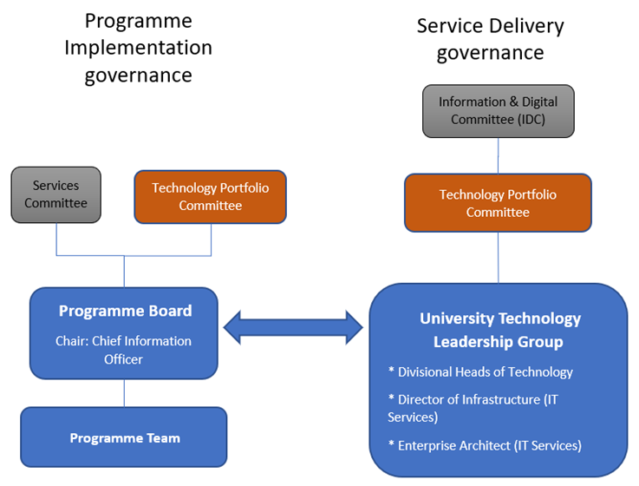
Proposed governance approach

Programme Team
Funded by the Digital Transformation Programme, a multidisciplinary team, with membership seconded from across the University, will be formed to deliver the recommended changes. The team will comprise a Programme Manager, change managers, specialists from across the divisions and professional services (including IT, HR and Finance), as required. The team will be led by the Programme Manager and will be overseen by a programme board. The Heads of Technology will act as senior suppliers and will provide strategic leadership and input into the delivery of the programme objectives.
The medium to long-term recommendations will be delivered by the programme team, supported by the catalogue of change ideas gathered during the diagnose and design phases of the review.
Pathfinder Project
To ensure a shared by default approach can be realised as soon as possible, it is recommended that the University carries out a Pathfinder project for early adopting departments to:
- Quickly identify opportunities for de-duplication and cost savings
- Address skills gaps and high-risk points of failure
- Agree a funding model to ensure strategic IT services (delivered by dept, div or centrally) are free at the point of use, recognising the principle of fairness and the need for appropriate standards of service and infrastructure across the University
- Demonstrate financial benefits of standardisation and identify early opportunities for consolidation or de-duplication
- Develop a common service management framework

High level implementation approach
As a result of the devolved nature of the University, Divisions are all at different starting points in their journey towards a shared way of working. The implementation approach will need to be flexible to accommodate different paths and opportunities for improvement in each area.
Ownership for the preparations required over the summer are to be determined during July and in accordance with approval of the recommendations.
Given the size and scale of the recommendations, there are a number of foundational recommendations which will need to be addressed before other recommendations can be considered, eg. appointment of a Programme Manager to oversee the changes required, and to support the appointment of the Divisional Technology Heads who will be instrumental in the divisional implementations plans for delivery of the other recommendations.
The SAM model will need to be revisited as the changes are implemented to ensure alignment with the aspirational goals of level 5.

Next Steps
Assuming the recommendations are endorsed by IT Committee and approved by Services Sub-committee, the next stage of work will involve handover to the implementation team – detailed plans for this will be developed with the Digital Transformation programme team during July.

Appendices
Appendix: Model Examples
Appendix: Table of Recommendations

