Risk mapping
Continuous Improvement
Benefits at a glance …
- Identifies potential project obstacles early
- Builds in proactive risk mitigation strategies
- Improves decision-making and chances of success

What is it?
Risk mapping helps identify a project or initiative’s success factors (what the project depends on in order to deliver) and potential obstacles, understand how concerned to be about them and decide how best to mitigate them.

When to use it?
Incorporate risk mapping into any change initiative. Use when getting started as part of developing a robust approach to the initiative. Regularly review and update the map as the initiative progresses, to keep on top of the crucial actions identified at the outset and to add any emerging risks and new mitigations as needed. This ensures effective risk mitigation strategies, enhances decision-making, and safeguards project success.
Download the Risk map template

How to use it?
The first step is to brainstorm what could go wrong. Doing this collaboratively with those involved in the project or initiative is really important. Stay open-minded: if a colleague suggests factors that you don’t perceive to be risks, include them anyway. Better safe than sorry, and the tool is designed to handle prospective risks that are unlikely to occur and/or would have little impact if they did.
This involves ‘re-setting’ the way you think about the initiative as, naturally, initiatives get started by thinking about what success looks like and how to get there. It can be harder to conceive of things that might go wrong, so try asking yourself and others questions like the following, and see where they take you:
- What potential obstacles are there to making progress?
- How might external factors impact the initiative?
- Are there resource limitations or shortages?
- Are key partners guaranteed to be available and willing to participate when you need them to?
- What compliance issues could arise?
- Could technology failures disrupt progress?
- Could customer requirements change during the improvement initiative?
- What risks are associated with team dynamics? Are the staff who will be delivering the improvements available and equipped to do so?
- How could financial uncertainties affect progress?
- Are there sustainability factors to take into account?
- What unexpected events might hinder success?
Try to be systematic in your approach: for example, ensure that all of the actions that form part of the projects are covered. Draw on stakeholder mapping and voice of the customer for help.
Having brainstormed potential problems, it’s time to plot them onto the matrix.

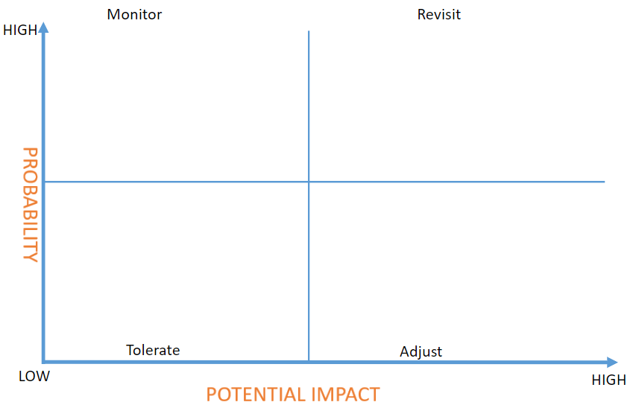

Use the quadrant details below to help you decide:
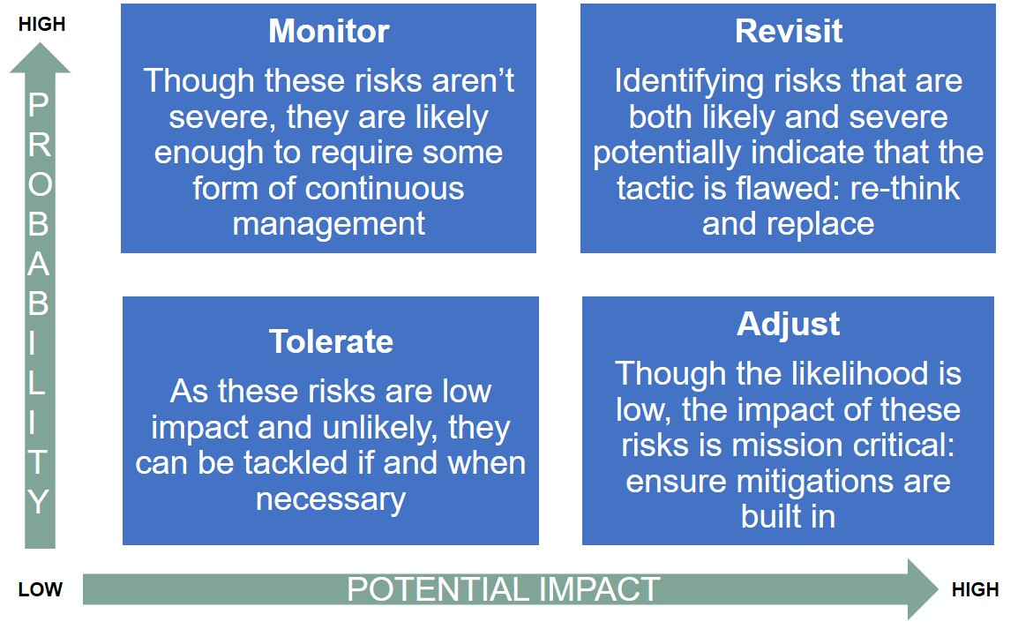
Using this information can help you prioritise the mitigations and other actions required to reduce or remove the risks.

