Stakeholder mapping
Engage
Benefits at a glance …
- Enhances quality by aligning decision-making with stakeholders’ needs and preferences
- Helps to manage stakeholder expectations, reducing conflicts
- Fosters stakeholder support and commitment to the initiative

What is it?
Stakeholder mapping is a technique for identifying individuals or groups with an interest in a project or initiative, understanding their influence and level of importance and deciding how best to gather feedback from and share information with them.

When to use it?
Use stakeholder mapping at the beginning of any change initiative. It steers you towards the benchmark for your decision-making – putting staff, students, academics and other stakeholders at the heart of our services – and helps you pick the best way to communicate with them.
Return to the tool throughout the initiative – stakeholders’ interest in and influence on the work may vary from stage to stage, or the relevance of an individual or group not identified at the outset may emerge and need to be added.
The tool can also be useful in general operations, to guide service delivery in a stakeholder-centric way.
Download a stakeholder map template

How to use it?
The first step is to identify the stakeholders, for example, loosely defined, people or groups of people who can affect or be affected by a given project/service/activity/role. They may be actively involved in operations/project delivery, affected by operational/project outcomes, or in a position to affect operational/project success. Devising the stakeholder list in collaboration with colleagues involved in the project or initiative is a really important step in managing projects.
Next, consider where on the matrix each stakeholder sits.
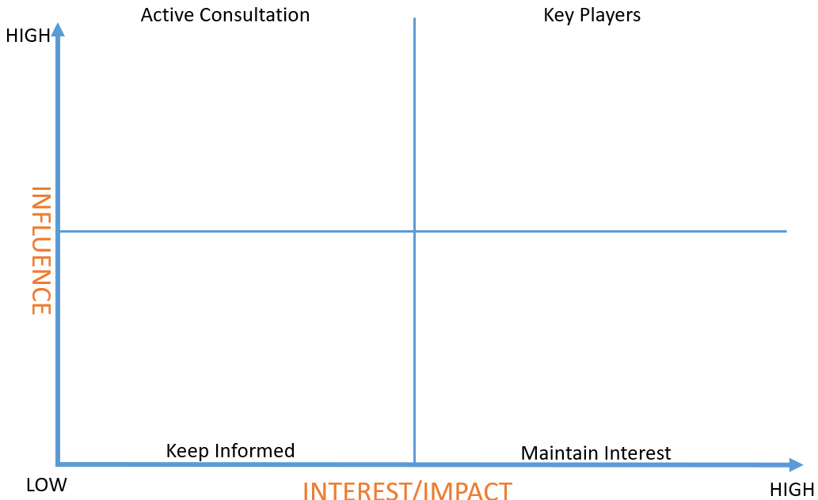
Figure 1. Stakeholder matrix
Use the quadrant details below to help you decide:
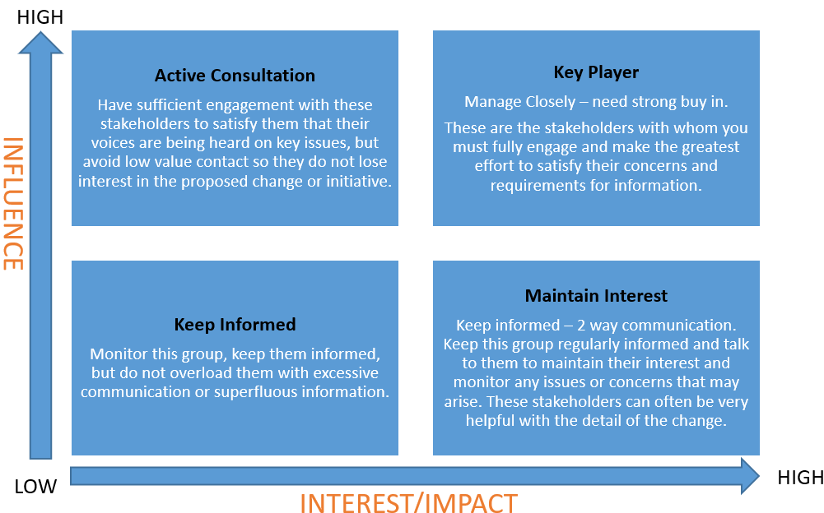Figure 2. Quadrant guidance
For each quadrant you will also need to build a communication plan – building up the different engagement activities for the different groups. Wherever possible use existing communication and engagement channels e.g. existing groups and committees, to improve the success of your engagement.

Tips
Remember this should be a living document – groups/stakeholders may move quadrants during the project timeline, so allow allow time to map and re-draft.
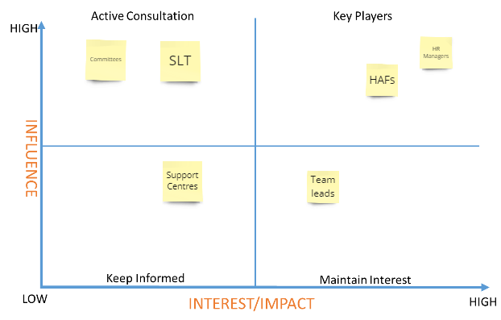
Figure 3. Draft example

